

**University of Rajshahi**

**Department of Computer Science and Engineering**

**Course Outline**

**Course Title:** Microprocessor and Assembly Language

**Course Code:** CSE 3231

**Course Type**: Theory

**Credits**: 3

**Prerequisite Knowledge:**

CSE1121 Structural Programming Language

EEE1131 Basic Electronics

CSE1211 Introduction to Digital Electronics

CSE2111 Digital System Design

CSE2231 Computer Architecture and Organization

**Year and Semester:** 3rd Year, Even Semester, 2023

**Class Room:** 219

**Instructor’s details:**

**Name:** Dr. Shamim Ahmad

**Designation**: Professor

**Web**: www.ru.ac.bd/cse

**Office Room**: 121 (Ground Floor, North Block)

**Tutorial Hours**: Will be provided once the situation for COVID-19 is over.

**Contact Email**: [shamim_cst@yahoo.com](mailto:shamim_cst@yahoo.com)

**Official Profile Link**: [http://rurfid.ru.ac.bd/ru_profile/public/teacher/22701143/profilee](http://103.79.117.242/ru_profile/public/teacher/22701143/profile)

**Virtual Learning Platform (if necessary):**

Zoom (PMI 427 888 6753)

Google Classroom (ID rfytcf2)

**Google Drive Link:**

<https://drive.google.com/drive/folders/1mPBwViHtrWtniIyaBwYOiA1-mcdv4Gzg?usp=sharing>

**Youtube channel of Students’ Presentation**:

<https://www.youtube.com/playlist?list=PLBOqIevWCE2Qw-DTTfmjhENBa1TV_aq5w>

**Motivation of Course:**

To develop knowledge on Microprocessor and Microcontroller architecture and programming skills with STM32 microcontroller

**Course Objective:**

This course introduces engineering students with the 8085/8086 Microprocessors, ARM processor and their programming. The course mainly is focused on Cortex M3/M4 processor and will provide a good understanding of its architecture, register sets, instruction sets, operation modes, addressing modes, memory system, Interrupts. However, this course will also give a brief introduction of older 8085/8085 processors.

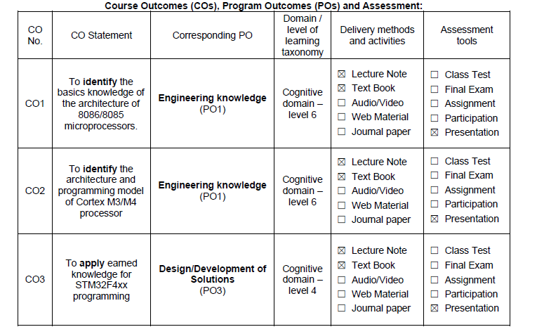

|  |
| --- |
| **Examination, Assessment and Marks Distribution:**  Students will be assessed on the basis of their overall performance in all the exams, class tests, assignments, and class participation. Final numeric reward will be the compilation of:  Class tests + Assignments due in different times of the semester (20%)  A comprehensive final exam (70%), **Total Time: 3 hours.**  A class participation mark (10%).  **CO2 and CO3: CO1**: Evaluated by final exam  **Date for Final Examination:** The date for final examination will be announced by the Department.  **Date for Class Test and Presentation:** Will be notified in Google Classroom |
| |  |  |  |  | | --- | --- | --- | --- | | **Sources:** 1. | STMicroelectronics www.st.com | : | **STM32F101xx, STM32F102xx, STM32F103xx and STM32F105xx/STM32F107xx Reference manual** *(RM0008)*  **STM32F10xxx Cortex®-M3 programming manual** *(PM0056)*  **STM32F10xxx Flash memory programming manual** *(PM0075*)  **STM32F10xxx XL-density Flash memory programming manual** *(PM0068*) | |

|  |  |  |  |
| --- | --- | --- | --- |
| **Books Recommended:**  1. | Ytha Yu and Charlers Marut | : | **Assembly Language Programming and Organization of the IBM PC,** *McGraw- Hill* |
| 2. | Ramesh Goanker | : | **Microcomputer Interfacing,** *McGraw-Hill* |

**Course Conducting/Course Policies:**

1. It is the student’s responsibility to gather information about the assignments and covered topics if he/she does miss the lecture
2. Regular class attendance is mandatory. Points will be taken off for missing classes.
3. Without 70% of attendance, sitting for final exam is **NOT allowed**.
4. The students must enter the **classroom in time** to get the attendance. **No student** will be allowed to enter the classroom after the attendance has been done.
5. Once the attendance is done, a student can leave the class if he or she thinks that he or she is not getting benefits from the class
6. The reading materials for each class will be available at the **above given link** prior to that class so that student may have a cursory look into the materials.
7. The date and syllabus of quiz/class test will be announced in time in google classroom
8. Students will be **notified** in due time for class cancelation, extra class, make-up class and tutorial class.
9. Students are encouraged to participate in the class discussion and to **ask questions**. The student can ask any question without any **hesitation as long as he or she can’t understand** the topics being discussed; please keep in mind that if you don’t understand, it’s not your fault, it’s my limitation that I could not make you understand. The class is expected to be interactive. The class is expected to be **interactive.**
10. Each student will have to present an online oral presentation **for 15 minutes** on practical assignment
11. It is expected that the student will also provide some new knowledge related to the curriculum and then make the class as a **place of knowledge sharing among all participants, both teacher and students**.
12. Any attempt for **unfairmeans** in the examination is **strictly prohibited**.

**Class & Exam Schedule, Topics and Readings:**

|  |  |
| --- | --- |
| **Sessions** | **Topics** |
| Week-1 | Introduction and Review of MC |
| Week-2 | Extensive use of IC Packages |
| Week-3 | Introduction of Microprocessor |
| Week-4 | 8085 Architecture |
| Week-5 | Fundamental of Address decoding |
| Week-6 | Address decoding with 8085 |
| Week-7 | 80856 Architecture |
| Week-8 | Cortex M3 Programming model |
| Week-9 | Cortex M3 Instruction set |
| Week-10 | Cortex M3 Instruction set |
| Week-11 | STM32F103 datasheet |
| Week-12 | STM32F103 programming |
| Week-13 | STM32F103 programming |
| Week-14 | Final Exam |